faith_3194.tiflife3c.tifNEWS OF WARTBURG PARISH

P.O. Box 185, Campbell Hill, IL

FEBRUARY 2022

*FROM MINISTER MICHAEL……*

|  |
| --- |
| Grace and Peace to you all.  The word Lent comes from the “lengthening” of daylight hours as we progress from the darkness of winter to the new light of spring.  Cold, icy, snowy, dormant trees and grass, no colors of flowers, no singing birds, no signs of new life. But a promise of new life lingers in the distance.  Ash Wednesday just 2 ½ weeks away to remind us that we are simply ash and to ash we will return. The earth from once we were formed by our Lord in his image. The earth needed to grow the seed for life seems to lay dead.  It will lay in a somewhat dead state seeming like no chance of growth for the 40 days of Lent, a time for us to reflect on what Jesus’ temptations, fasting and praying means for us.  But have you ever thought about why 40 days, all the temptations of the devil could have been done in a week or even a day. But to get the point across Jesus would show what he was willing to go through, anything and everything for the salvation of mankind.  The number 40: Noah and the ark 40 days and nights of rain. Moses up on Mt. Sinai 40 days and nights to receive the 10 commandments. The Israelites wandered around the desert for 40 years.  So why all these forties? Probably because it is forty weeks that a woman carries her developing baby before a new life can come forth from the womb.  All these “forties” are a necessary and not-so-comfortable introduction for something new. In Noah’s case, it’s the rebirth of a sinful world that had been cleansed by raging flood waters.  In Moses’ case, it was the birth of the people of the covenant.  For the wandering Israelites, it was the start of a new, settled existence in the Promised land.  And Jesus Christ? What did his forty days in the wilderness signify? The imminent birth of a new Israel liberated from sin, reconciled to God, and governed by the law of the Spirit rather than a law chiseled in stone.  Jesus triumphs in this first wrestling match. He shows us how to keep from being pinned. [Fasting](about:blank) breaks undue attachments to material blessings and stimulates our spiritual appetite. [Humble service](about:blank) breaks the stranglehold of pride.  The reverent worship of authentic faith breaks the full nelson of superstition, magic, and all arrogant religion. And the word of God is shown as the sword of the Spirit, the secret weapon that slashes through the enemy’s lies.  So our forty days? Time to use the tactics modeled by our captain and break the strongholds. Prayer, fasting, humble service.  The heavenly bread of the Eucharist and the Word of God. If we make use of them diligently during this season, pregnant with possibilities, we can enter into greater freedom.  Darkness can give way to increasing light. Something new and wonderful can be born in us.  Darkness is gone and Gods’ light shines forever.  Let that newness of light shine in you always. |
|  |

++++++++++++++++++++++++++++++++++

[](http://www.google.com/imgres?hl=en&tbo=d&biw=800&bih=378&tbm=isch&tbnid=LllAIQDWMEVf6M:&imgrefurl=http://www.lcdr-sd.org/Confirmation%20Page.html&docid=8KiSksUKQnnkSM&imgurl=http://www.lcdr-sd.org/Pictures%20only/Confirmation%20Class%202.jpg&w=1557&h=1412&ei=f9H-UMyqBoK6qgHXhICYAQ&zoom=1&iact=hc&vpx=106&vpy=28&dur=47&hovh=214&hovw=236&tx=89&ty=99&sig=109264132955687629760&page=2&tbnh=146&tbnw=161&start=10&ndsp=15&ved=1t:429,r:16,s:0,i:196)Confirmation – During the season of Lent we are strongly urging all confirmation students to join us at 7:00 on Wednesday evenings at the Midweek Lenten Services. The last class before Lent is February 23 and will begin again on April 20. The Wartburg Parish has two who will be confirmed this year. They are Connor Brown from St. John, Post Oak and Carson Rednour from St. Peter, Wine Hill.

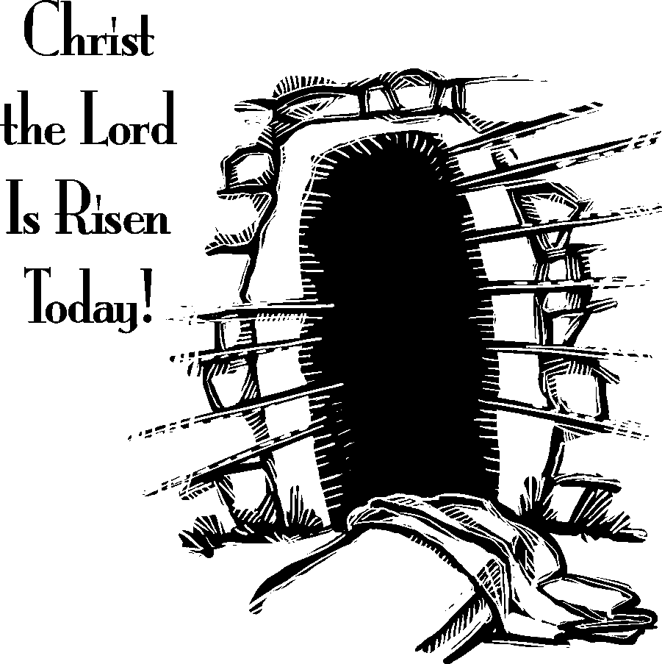

*Parish Congregational Services for Ash Wednesday*

*Holy Week*

St. John, Post Oak

Ash Wednesday, March 2, 5:30pm, Worship with Holy Communion and the Imposition of Ashes.

If you are unable to attend at this time, St. Peter’s, Wine Hill, will have their service at 7:00pm.

Palm Sunday, April 10, 8:30am, Worship Service with Procession of Palms and Holy Communion

Maundy Thursday, April 14, Joint Service with Wine Hill at Post Oak, 7:00pm Worship

with Holy Communion

and Stripping of the Altar

(6:00 Soup Supper is Pending)

Good Friday, April 15, 7:00pm, Joint Service

with Wine Hill at Wine Hill.

Easter Sunday, April 17, 7:00am Sunrise

Service with Easter Egg Hunt

and Breakfast to Follow

8:30 am Easter Worship with Holy Communion.

St. Peter’s, Wine Hill

Ash Wednesday, March 2, 7:00pm Worship with Holy Communion and the Imposition of Ashes.

If you are unable to attend at this time, St. John, Post Oak will have their service at 5:30pm.

Palm Sunday, April 10, 9:00am Sunday School

10:00am Worship with Holy Communion

Maundy Thursday, April 14, Joint Service with Post Oak at Post Oak, 7:00pm Worship

with Holy Communion and

Stripping of the Altar

(6:00 Soup Supper is Pending.)

Good Friday, April 15, 7:00pm, Joint Worship

Service with Post Oak at Wine Hill

Easter Sunday, April 17, 9:00am Full Breakfast

with Easter Egg Hunt to Follow.

10:00am Easter Worship with Holy Communion

Peace, Chester

Ash Wednesday, March 2, Service Pending

Palm Sunday, April 10, 10:30am Worship

Service

Maundy Thursday, April 14, Service Pending

Good Friday, April 15, Service Pending

Easter Sunday, April 17, 10:30am Easter Worship

*PEACE, CHESTER WILL BE HOLDING THEIR*

*SPRING RUMMAGE SALE*

*ON FRIDAY, APRIL 29*

*AND SATURDAY, APRIL 30*

*7:00am to 4:00pm. EACH DAY.*

\*\*\*\*\*\*\*\*\*\*\*\*\*\*\*\*\*\*\*\*\*\*\*\*\*\*\*\*\*\*\*\*\*\*\*\*\*\*\*\*\*\*\*\*\*\*\*\*\*\*\*\*\*\*\*\*\*\*\*\*\*\*\*\*\*\*\*\*\*\*\*\*\*\*\*\*\*\*\*\*

PRAYER FASTING HUMBLE SERVICE

\*\*\*\*\*\*\*\*\*\*\*\*\*\*\*\*\*\*\*\*\*\*\*\*\*\*\*\*\*\*\*\*\*\*\*\*\*\*\*\*\*\*\*\*\*\*\*\*\*\*\*\*\*\*\*\*\*\*\*\*\*\*\*\*\*\*\*\*\*\*\*\*\*\*\*\*\*\*\*\*

 WARTBURG PARISH MIDWEEK LENTEN SERVICES

The Wartburg Parish invites you to join us for worship on Wednesdays throughout the season of Lent.

Wednesday Evenings at 7:00 – Rotating Schedule

There will be no Soup Supper before the services due to the pandemic.

March 9 at St. John, Post Oak

Our theme verse for today is, “And when they

had sung a hymn, they went out to the

Mount of Olives.”

March 16 at St. Peter’s, Wine Hill

Our theme verse for today is, “Then Jesus went

with them to a place called Gethsemane,

and he said to his disciples, ‘Sit here

while I go over there and pray.’”

March 23 at Peace, Chester

Our theme verse for today is, “Now Peter was sitting

outside in the courtyard. And a servant girl came up

to him and said, ‘You also were with Jesus the Galilean.’

But he denied it.”

March 30 at St. John, Post Oak

Our theme verse for today is, “Pilate said to them,

‘Then what shall I do with Jesus who is

called Christ?’ They all said,

‘Let him be crucified.’”

April 6 at St. Peter’s, Wine Hill

Our theme – God’s ways are not our own.

We expect a conquering king and hero, but

Jesus instead leads us down the road to

Jerusalem and humbles himself of the cross.

God changes our plans and replaces them with

a love broader and deeper than anything

we could imagine.